**Q7)Ansible**

**1) Why did this error occur?**

The error message indicates that Ansible was unable to locate a package named python3 in the package repositories on server2. Here are some possible reasons for this issue:

* Older Python Versions: The system may only have older versions of Python installed, such as python2.
* Different Package Managers: The server might be using a different package manager than expected. For example:
  + Ubuntu/Debian: Uses apt
  + Red Hat/CentOS: Uses yum or dnf

**2) How can you modify you playbook to handle this issue dynamically using ansible facts?**

To address this issue dynamically in your Ansible playbook, you can leverage Ansible facts to determine the operating system and its package manager. Below is an example of how to modify your playbook using the when clause to install python3 based on the detected OS.

**3) Write a playbook snippet that ensures python3 gets installed correctly on any Linux distribution?**

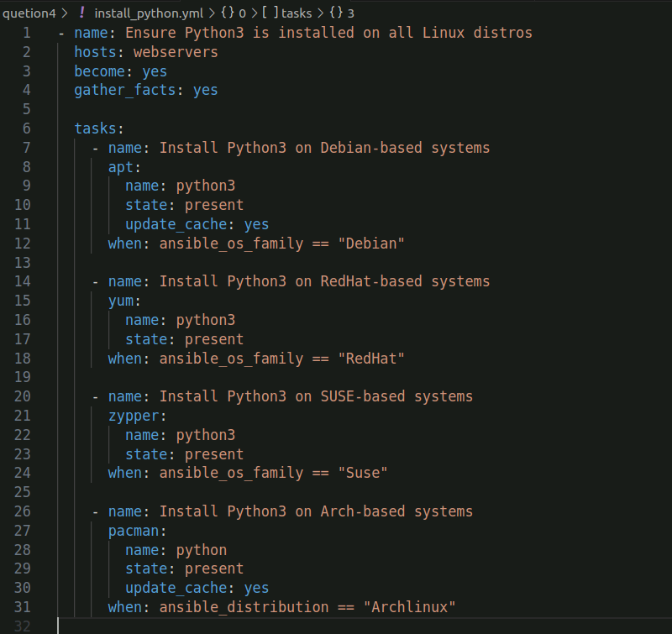

**Run playbook**

